**EXPERIMENT 3**

**Aim:**

Write a program in ARM Assembly language to copy consecutive words from source to destination in memory using:

1. Multiple register transfer instructions
2. Load and store instructions in a loop

**Tool used:** Keil uVision4

**Theory:**

Here I have used LSL, LSR and ASR for shifting the bits. LSL is used for shifting the bits left and concatenate a 0 at the LSB. LSR is used for shifting the bits right and concatenate a 0 at the MSB. ASR is used to shift the bits right and concatenate the value of MSB at the new MSB

1. **Multiple register transfer instructions**

**Code: ­­**

 AREA PROGRAM, CODE, READONLY

 ENTRY

MAIN

 LDR R0,=­­0X00000000

 LDR R1,=0X00001000

 LDM R0!,{R2-R5}

 STM R1!,{R2-R5}

 END

**Register Output:**

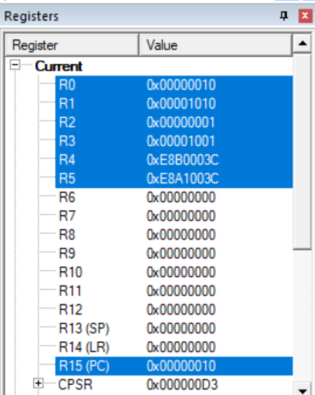

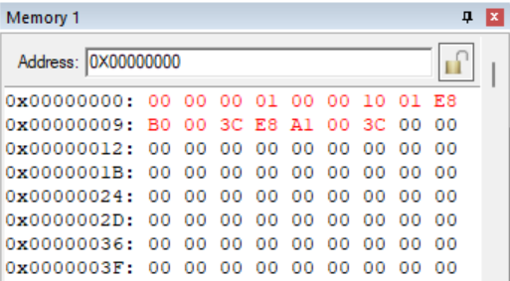

**Using IA, IB, DA, DB**

**Code: IA**

 AREA PROGRAM, CODE, READONLY

 ENTRY

MAIN

 LDR R0,=0X00001000

 LDR R1,=0X00001020

 LDMIA R0!,{R2-R5}

 STMIA R1!,{R2-R5}

 END

**Register Output:**

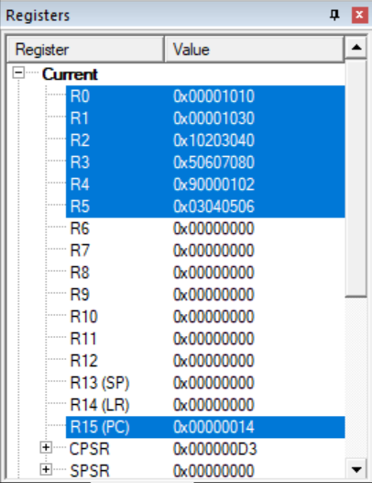

**Memory Mapping:**

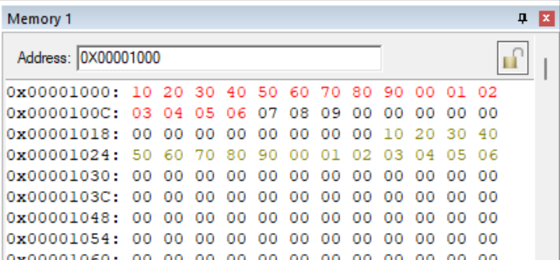

**Code: IB**

 AREA PROGRAM, CODE, READONLY

 ENTRY

MAIN

 LDR R0,=0X00001000

 LDR R1,=0X00002000

 LDMIB R0!,{R2-R5}

 STMIB R1!,{R2-R5}

 END

**Register Output:**

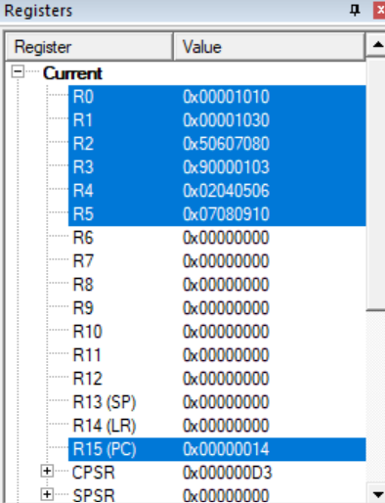

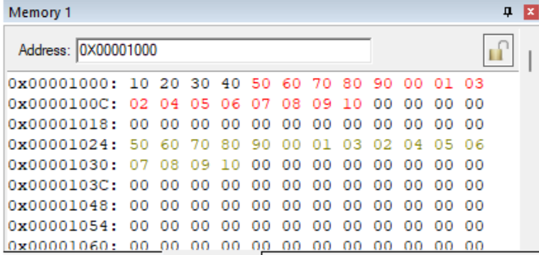

**Code: DA**

 AREA PROGRAM, CODE, READONLY

 ENTRY

MAIN

 LDR R0,=0X00001000

 LDR R1,=0X00001020

 LDMDA R0!,{R2-R5}

 STMDA R1!,{R2-R5}

 END

**Register Output:**

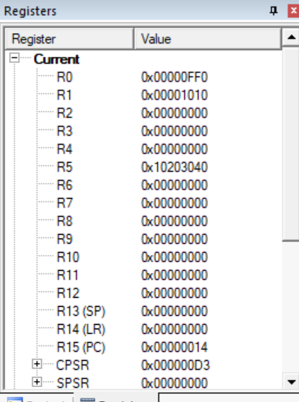

**Memory Mapping:**

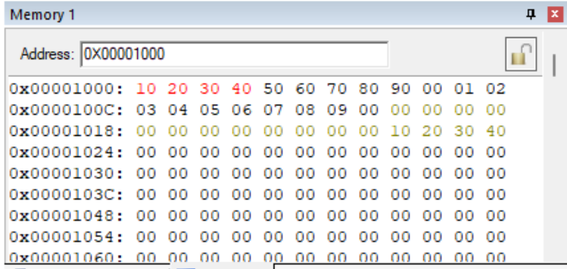

**Code: DB**

 AREA PROGRAM, CODE, READONLY

 ENTRY

MAIN

 LDR R0,=0X00001000

 LDR R1,=0X00001020

 LDMDB R0!,{R2-R5}

 STMDB R1!,{R2-R5}

 END

**Register Output:**

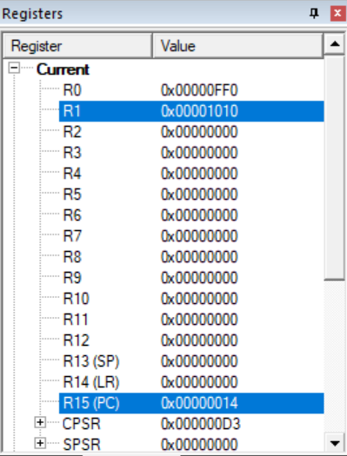

**Memory mapping:**

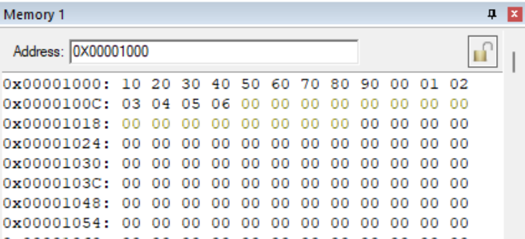

1. **Load and store instructions in a loop**

**Code:**

 AREA PROGRAM, CODE, READONLY

 ENTRY

MAIN

 LDR R0, =0X00000000

 LDR R1, =0X00000020

FOR

 LDR R3, [R0], #4

 STR R3, [R1], #4

 SUBS R2, R3, #1

 BNE FOR

 END

**Register output:**

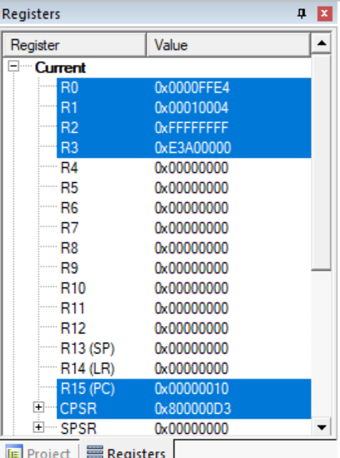

**Memory mapping:**

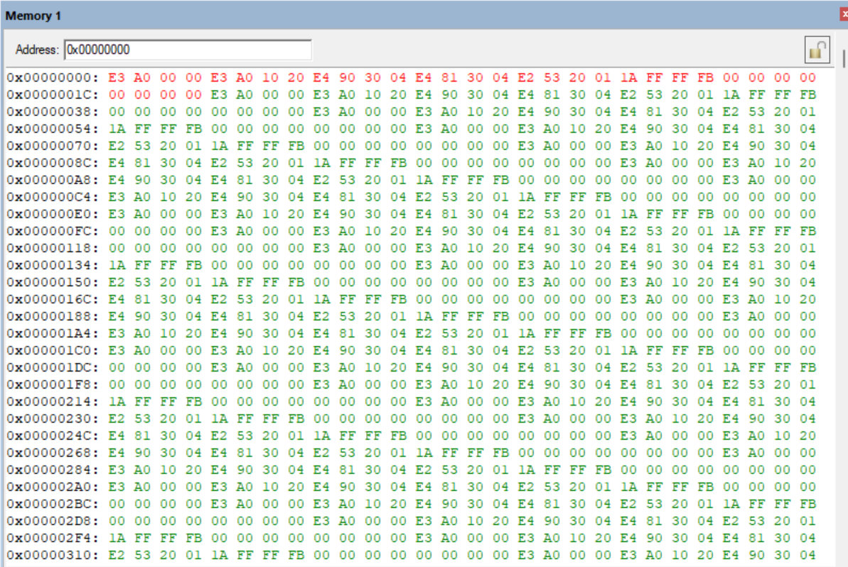

**Result:**

All the parts of the experiments are performed successfully and their results are also verified correctly.